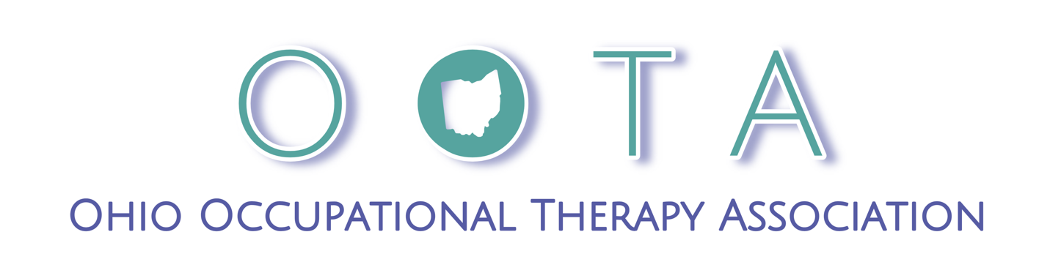

Frequently Asked Questions

Table of Contents
General FAQs 1
I received an email confirming my membership renewal, but I did not authorize this renewal. 1
I am a student conducting research, can OOTA send my research survey to members? 2
Learning Platform FAQs 2
What kind of DEVICE should I use for the best results? 2
What kind of BROWSER should I use? 2
What kind of INTERNET CONNECTION should I have? 3
I thought I was registered but when I try to go in and check it says "the form isn't available." 3
I don’t see the courses I purchased in “My Courses.” 3
I registered for the webinar. When I go in to access it, the links don't work. 3
How do I log in? 3
The course is not advancing after I have watched a video in a Lesson. What do I do? 3
Additional resources for common situations are available here to download: 3

General FAQs

I received an email confirming my membership renewal, but I did not authorize this renewal.

- Auto-renewal is selected at the time of renewal by the member.
- The auto-renewal is an option that we cannot turn on or off, it is only accessible by the member. You will have the option to access it when you go in and access your membership renewal next.
- You will receive a 30 day notice of renewal and then a week notice. When these come they allow you to go in and change any settings and/or manually renew prior to the auto-renew. You will be able to turn off auto-renew at that time.

I am a student conducting research, can OOTA send my research survey to members?

The Ohio Occupational Therapy Association is a strong supporter of evidence-based practice and the research required to obtain and support that evidence. We are also mindful of the large number of requests received by our members from other sources asking for their time and response. Accordingly, OOTA does not forward research or survey requests to our membership in an effort to maintain robust communications between the association and its members.

To support our members and still provide avenues for student research support:
- You are able to get a free list of all licensed occupational therapy practitioners in Ohio from the licensure board if you choose to do so. Th
- Current student members of OOTA can post their research project to the OOTA website Community Forum for research.

Learning Platform FAQs

What kind of DEVICE should I use for the best results?
- Desktop PC or Mac
- Laptop PC or Mac
- iPad or tablet
- Cellphone (a cell phone can be used, however, for the best experience we don’t recommended)
- DO NOT use a Chromebook! Due to Chromebook’s incompatibility with some video players, Chromebook will not work with our Learning Management System. Please use another device that is not a Chromebook.

What kind of BROWSER should I use?
- Chrome
- Firefox
- Edge
- Safari
- DO NOT use Internet Explorer! Microsoft has not supported or updated IE since 2015. IE should not be used at all for internet safety.

What kind of INTERNET CONNECTION should I have?
- Wi-Fi and LAN connections work best. When using Wi-Fi, it must be a strong connection. Don’t use public Wi-Fi. Public Wi-Fi has a lot of traffic on the signal, which is problematic. This will cause a lot of buffering and breaks in the connection.
- If you are using a smartphone, DO NOT use your data plan! A data signal is inconsistent, and you may have issues completing the full webinar as needed.

I thought I was registered but when I try to go in and check it says "the form isn't available."
- This indicates you are ALREADY registered.
- You need to log in to the learning platform and you will be able to access the course.

I don’t see the courses I purchased in “My Courses.”
- Log in (you must be logged in to access the course(s) you purchased).
- Click on the course that you purchased to load it into your account.

I registered for the webinar. When I go in to access it, the links don't work.
- You must be logged in to access webinars for both LIVE and ON DEMAND viewing.

How do I log in?
- You can log in using your OOTA login information.

The course is not advancing after I have watched a video in a Lesson. What do I do?
- You don’t need to watch the video again unless you want to.
- Make sure you don’t stop the video before it reaches the end.
- Give it a minute.
- Refresh the browser.
- When you begin a course DO NOT advance the video manually. This will affect your being able to advance to the next item in your course.

Additional resources for common situations are available here to download:
How do I access my LIVE webinar after purchase?
How do I access my ON DEMAND webinar after purchase?
How can I access my certificate if I've already completed the course and passed the quiz?

